32.43: a) 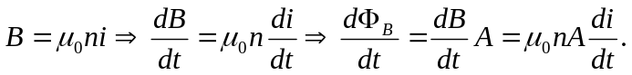
So, 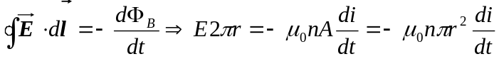
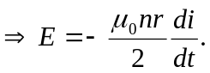

b) The direction of the Poynting vector is radially inward, since the magnetic field is along the solenoid’s axis and the electric filed is circumferential. It’s magnitude 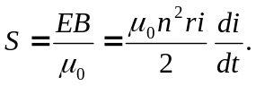
c) 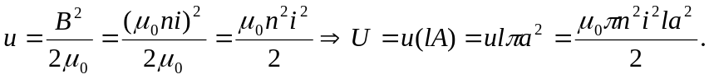
But also 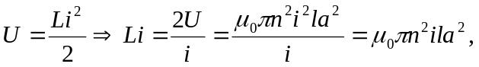 and so the rate of energy increase due to the increasing current is given by 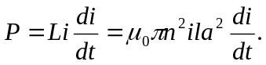
d) The in-flow of electromagnetic energy through a cylindrical surface located at the solenoid coils is 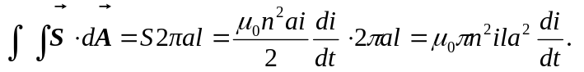
e) The values from parts (c) and (d) are identical for the flow of energy, and hence we can consider the energy stored in a current carrying solenoid as having entered through its cylindrical walls while the current was attaining its steady-state value.

